**SSVV EXAM Take-Home C**

**- documentation –**

<team members>

**Minutes required for the automated scenario:** 210’ (3h 30’)

**Test Report**

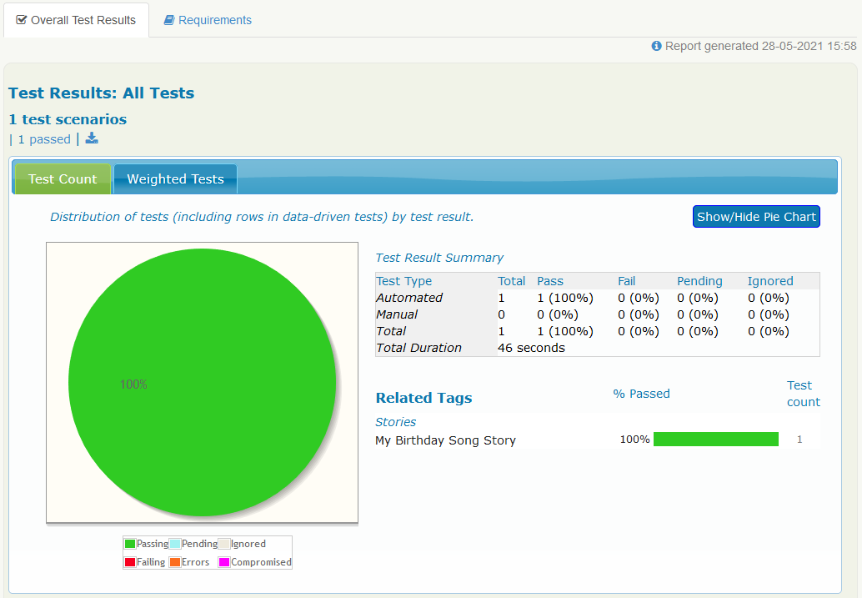

**How did you identify the Web Elements?**

We identified the web elements by using either the Selenium *@FindBy* annotation or the Serenity BDD *find* function on:

* IDs
  + e.g. *@FindBy(id = "searchInput"*)
* class names
  + e.g. *@FindBy(className = "findSong"*)
* tag names
  + e.g. *@FindBy(tagName = "strong"*)
* css selectors
  + e.g. *find(By.cssSelector("a[data-serp-pos='0']"))* )

**Explain the POM structure of Serenity that you used and benefits.**

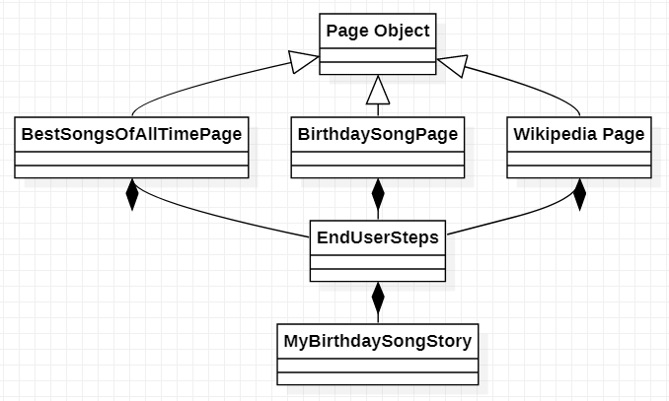

We used the POM structure in order to derive our page classes from the *PageObject* class - namely *BestSongsOfAllTimePage, BirthdaySongPage, WikipediaPage* – that were in turn used the *EndUserSteps* class on which the *MyBirthdaySongStory* would operate. This makes the code **maintainable, easy to understand and split on working units** by following the OOP principles: Single Responsibility Principle, i.e. no function does this AND that, but ONLY this; dependency inversion, by decoupling the software modules and classes.